Measurements for graduated cylinder and triple beam balance:::
- B)
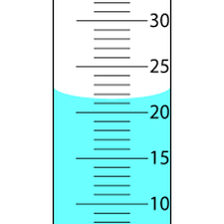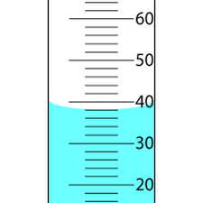

C)
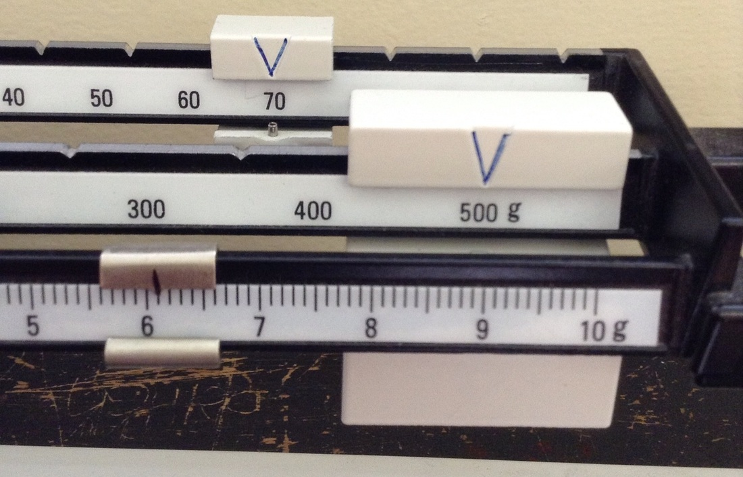

Answers:::
- 21.5 mL
- 38 mL
- 576.1 g

